Project Name

Tortoise Flips

Project outcomes

The BOT must be able to work on pips/range charts otherwise will need to rethink project

- BOT to enter/exit trades
- Chart markups
- CSV File output

Contents

- parameters
- indicators
- long position signals - to open and close
- short position signals - to open and close
- It would also be useful to add screenshots of trade entry & exit points.
- Explanations
- Example Trades

ADJUSTABLE PARAMETERS
- Session select –
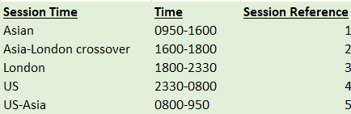

- Lookback Number – can be from 0 to infinte – default 3
- Offset for stop order – can be from 0 to infinite
- PSAR – default max is 0.08 – can be changed though
- Risk box
PSAR
opposite side of dragon
3x range of range on chart (multiple can be changed though – default is 3)

INDICATORS
All the indicators I need to use in my trading strategy are listed below, the indicators will be standard cTrader indicators or 3rd party indicators complete with source code.
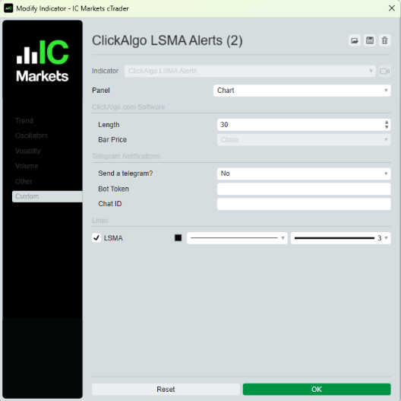
Indicators
LSMA 10
LSMA 30 (used for reference – not used in coding)
SMA 10 +-0.5SD
PSAR based off LSMA 10
LSMA 10 x SMA 10 +- 0.5SD (Dragon)
Bollinger band cloud on SMA 10

- LSMA 30 (RL30) (LSMA)

- LSMA Cross
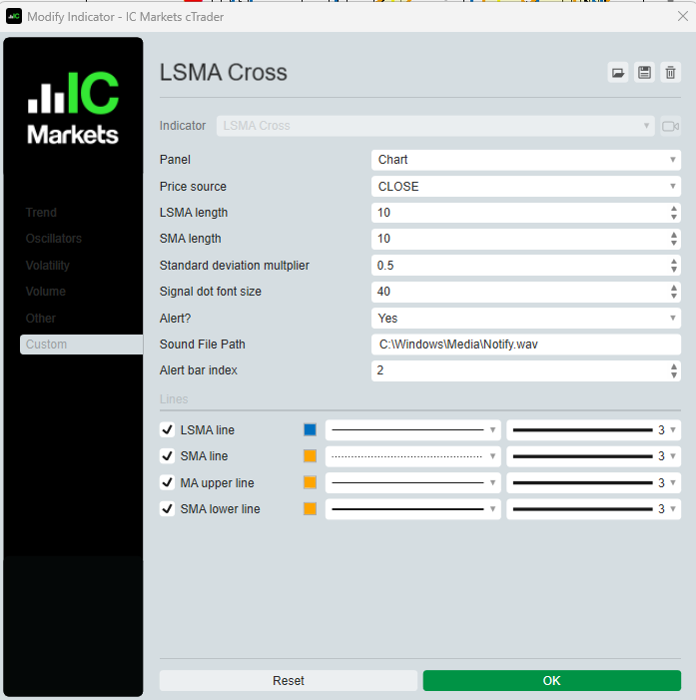
  - SMA 10 +- 0.5 (referred to as the dragon)
  - LSMA 10 (RL10)
  - Dots for RL10 crossing and closing on other side of dragon

- PSAR using LSMA (10)
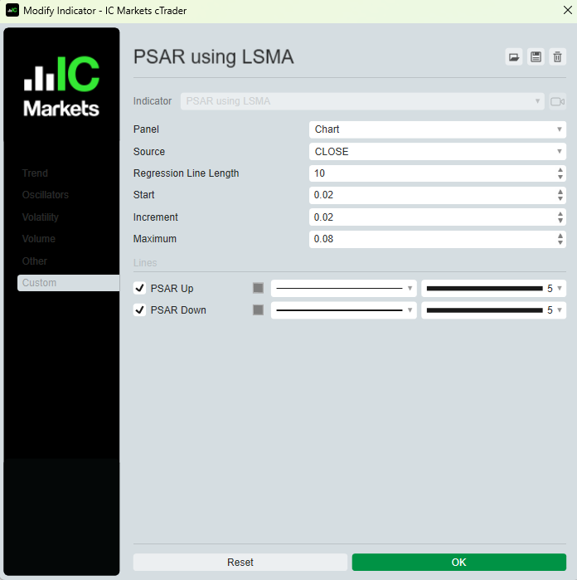
- Bollinger band cloud – to highlight yellow band

- Simple Moving Average (10) – (2 – LSMA Cross probably has this indicator in the code)
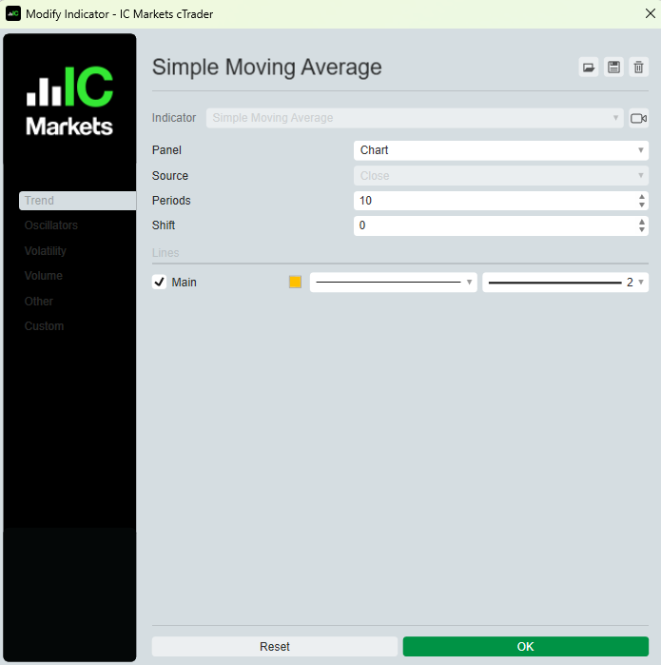

TRADES entry / exit

If risk box is never hit than there will always be a trade on.
The closing position signals for a LONG trade are the exact same signals for a SHORT trade.

Inputs / Variables / Definitions
RLXD define (Green / Red)
PSAR flip define
Lookback bars define
HH = Higher High
LL = Lower Low
Risk box

LONG TRADES

Opening a Position
All the signals below must be true to open a long (buy) position.

IF RLXD (Green) and PSAR flip (to long side)
THEN check for lookback bars for HH
REFERENCE PRICE
THEN add on offset to the REFERENCE PRICE to = ADJUSTED PRICE
STOP ORDER + 1 pip/tick
RISK BOX = VARIABLE set

Closing a Position
Close long when either 1 or 2 occurs whichever first (2 is the opening a position for a short) :

- Risk box hit
- IF RLXD (Red) and PSAR flip (Short)
THEN check for lookback bars for LL
REFERENCE PRICE
THEN deduct offset from the REFERENCE PRICE to = ADJUSTED PRICE
STOP ORDER - 1 pip/tick
RISK BOX = VARIABLE set

SHORT TRADES

Opening a Position
All the signals below must be true to open a long (buy) position.

IF RLXD (Red) and PSAR flip (to short side)
THEN check for lookback bars for LL
REFERENCE PRICE
THEN deduct offset from the REFERENCE PRICE to = ADJUSTED PRICE
STOP ORDER - 1 pip/tick
RISK BOX = VARIABLE set

Closing a Position
Close long when either 1 or 2 occurs whichever first (2 is the opening position for a long):

- Risk box hit
- IF RLXD (Green) and PSAR flip (Long)
THEN check for lookback bars for HH
REFERENCE PRICE
THEN add on offset to the REFERENCE PRICE to = ADJUSTED PRICE
STOP ORDER + 1 pip/tick
RISK BOX = VARIABLE set

Explanations

RLXD
Regression line / LSMA 10 crosses and closes on (x) the opposite side of the dragon (SMA 10+-0.5 SD)
Green dot is when RLXD crosses the dragon for long bias
Red dot is when RLXD crosses the dragon for short bias
Have the algo for this - attached
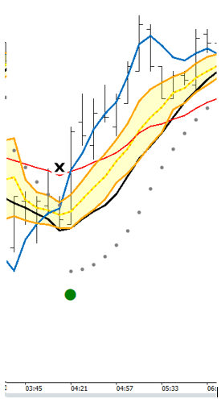

Dragon

(SMA 10+-0.5 SD)

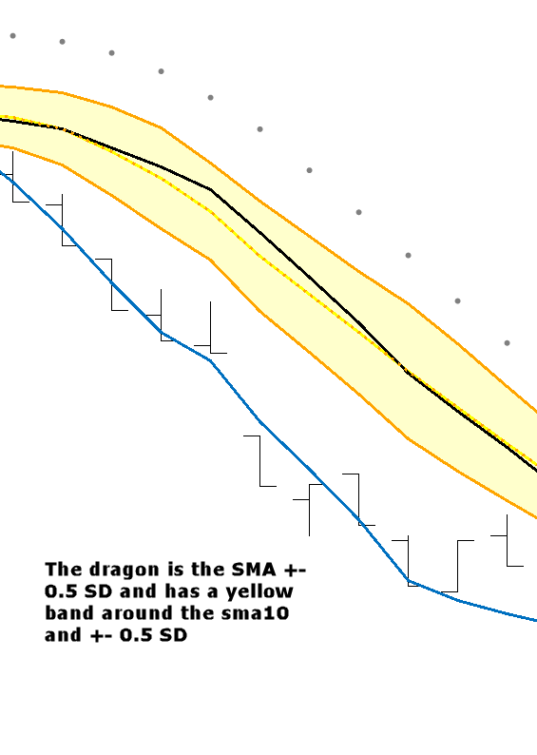
PSAR flip = PSAR flip to Long or Short bias – based off RL10 or LSMA10 not price

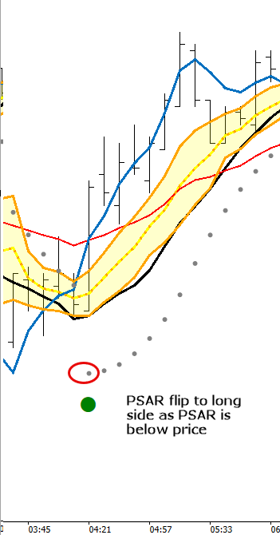

Risk box
The amount of risk on a trade is measure to one of the following values:
- PSAR – default setting – entry price to PSAR value is risk box
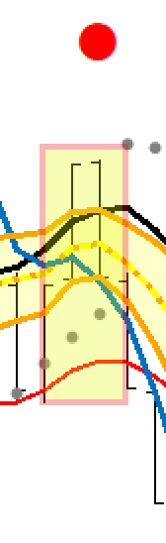

- Opposite side of dragon

For the other side of the dragon it will be the HIGHEST / LOWEST value of the opposite side of the dragon(SMA-0.5SD for longs and SMA+0.5SD for shorts) for the last 5 bars

- 3x range of range on chart
If the range of the chart is 35 pips, then the risk box will be 3x35 = 105pips
Lookback bars define
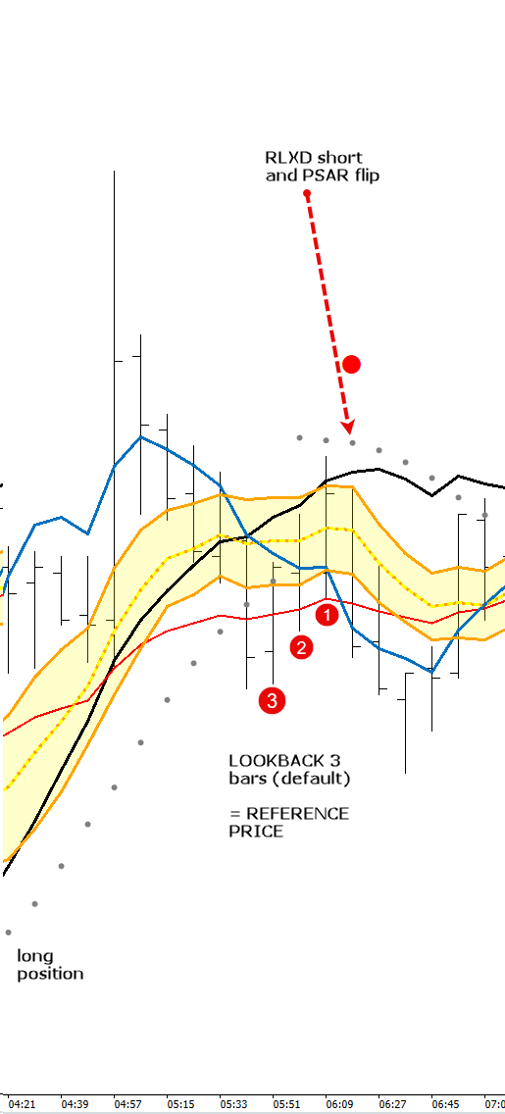

Lookback bars and offsets explained

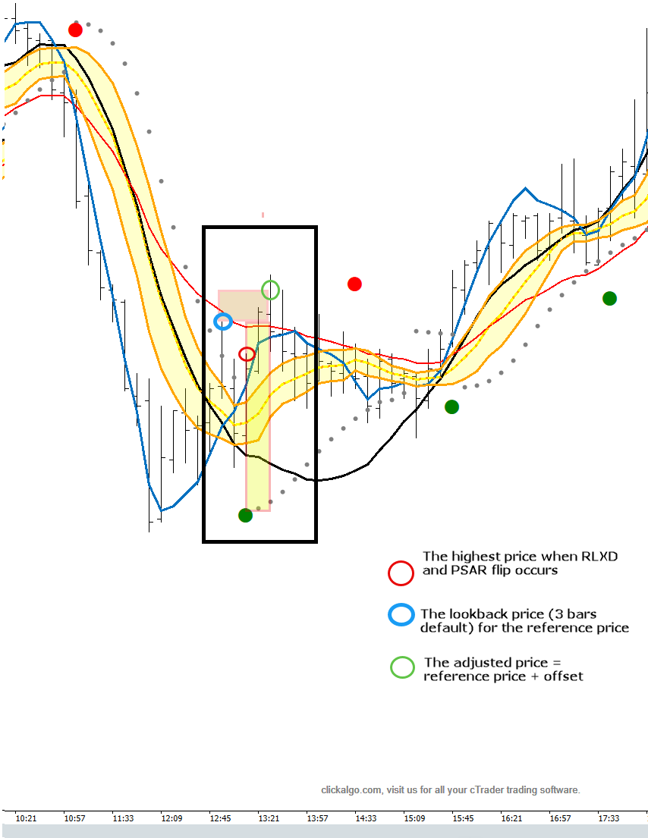

Chart Mark-Ups

Can you tell me if any or all of this is possible in cTrader.
Need to get the entries marked up with risk box and offset – the actual gain/loss the Maximum Favourable Excursion and Maximum Adverse Excursion.

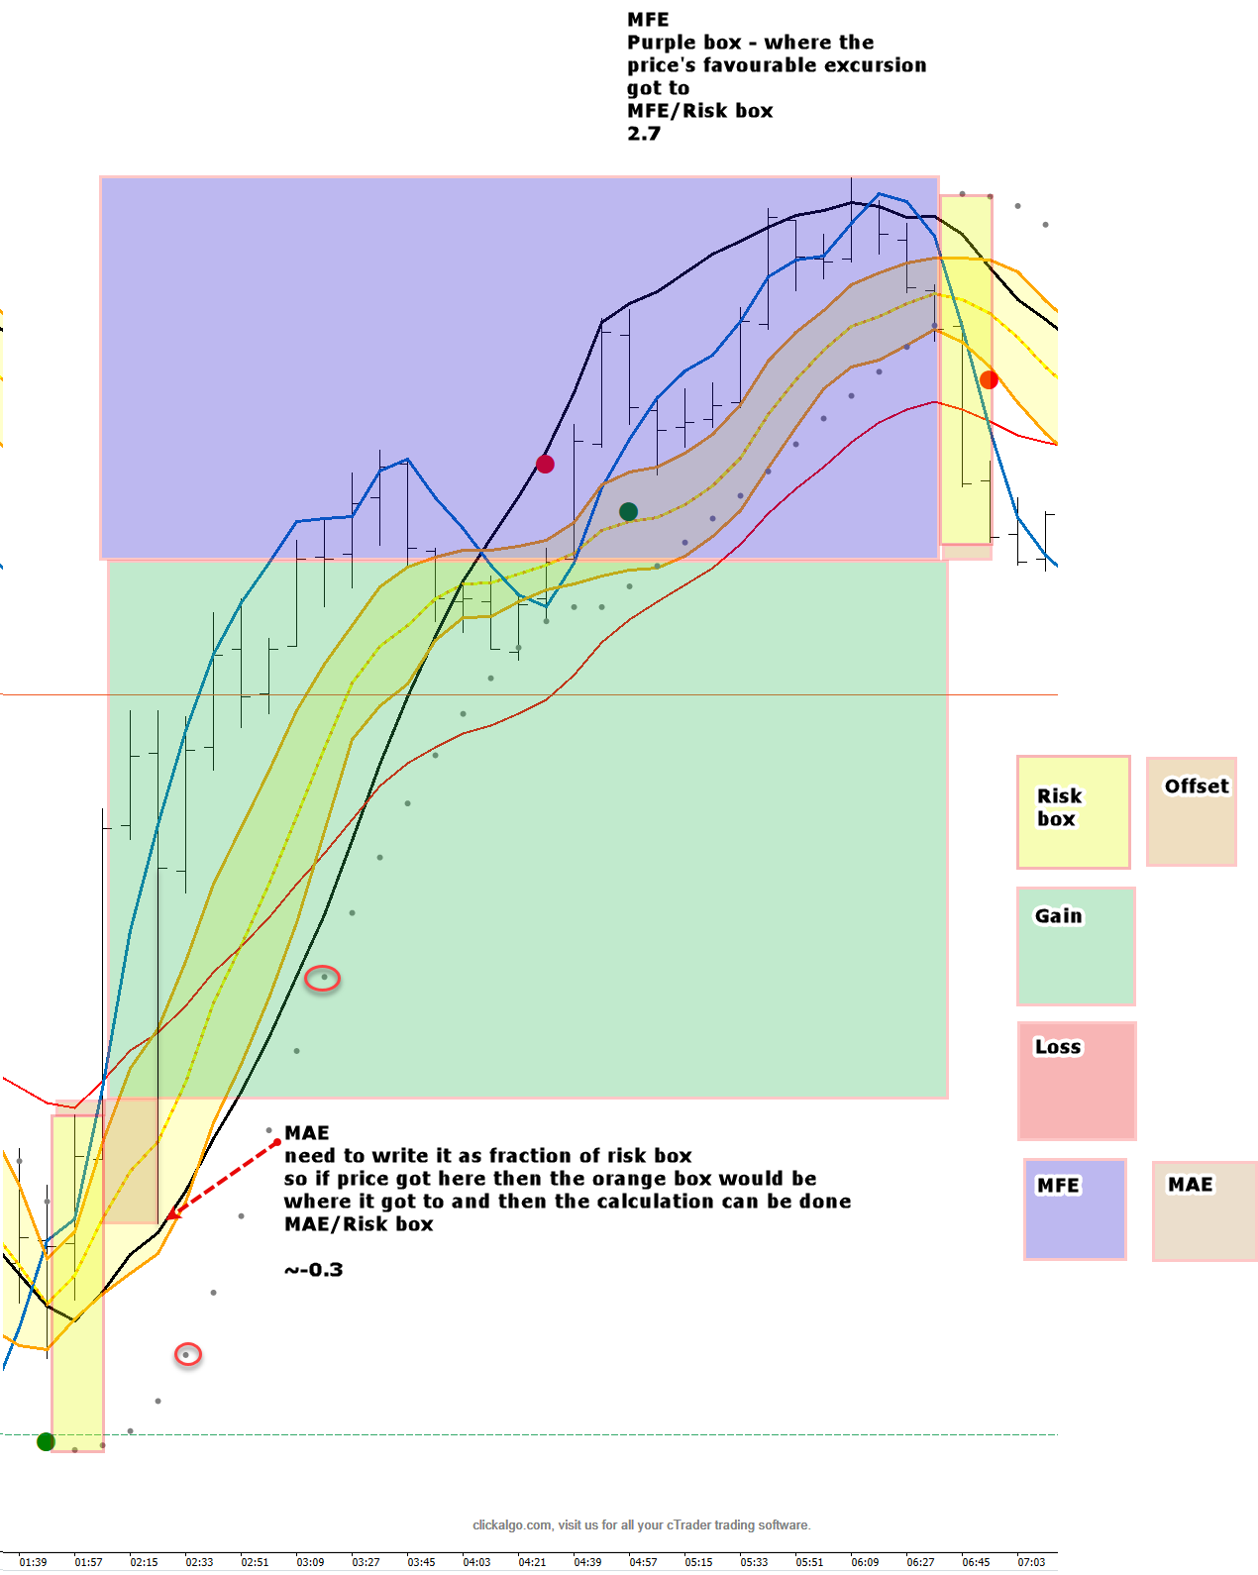

CSV output

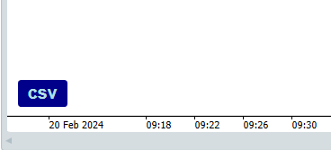

A previous coder has been able to code a script to export specific details to a CSV file. This was not via a bot it was via an indicator. If possible is there any way to get the following information exported to a csv file for each trade.

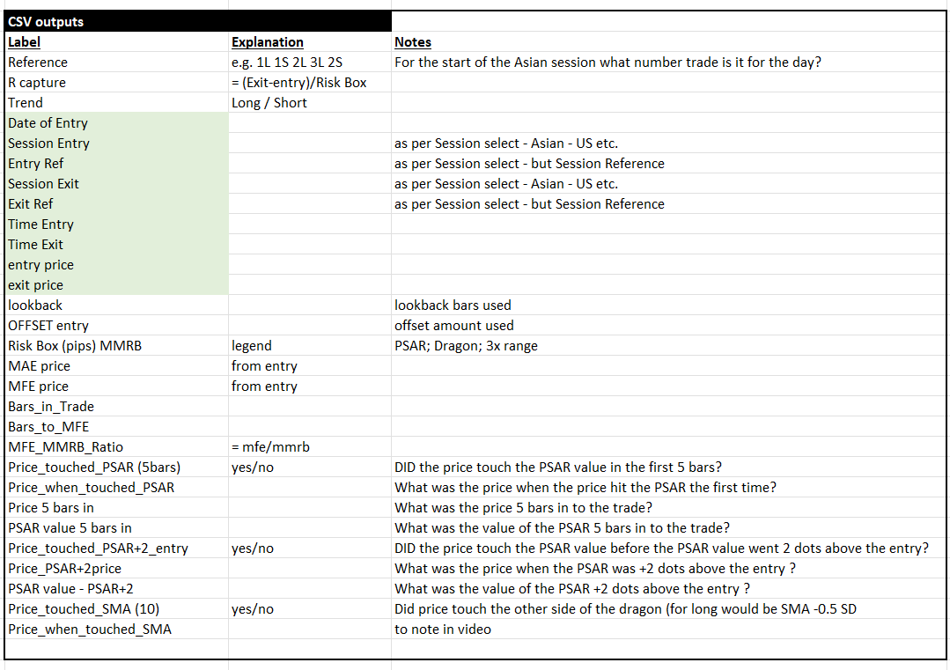

Examples
